Lab 4 _ Ex 1-4 Report
  - Đỗ Hoàng Mỹ Dung – ITITWE21040
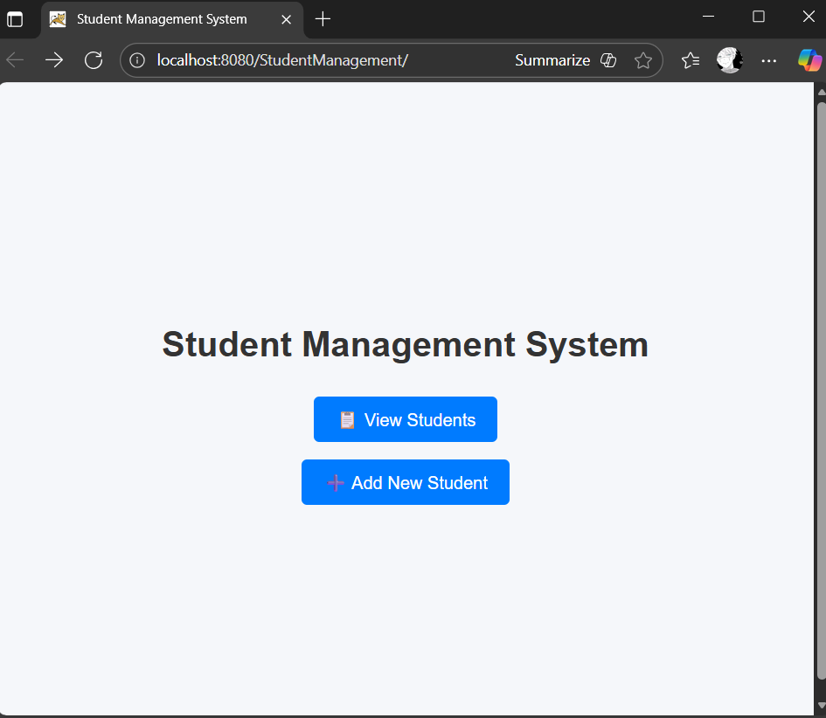
Figure 1: index.html

EXERCISE 1: SETUP AND DISPLAY

Task 1.1: Project Setup
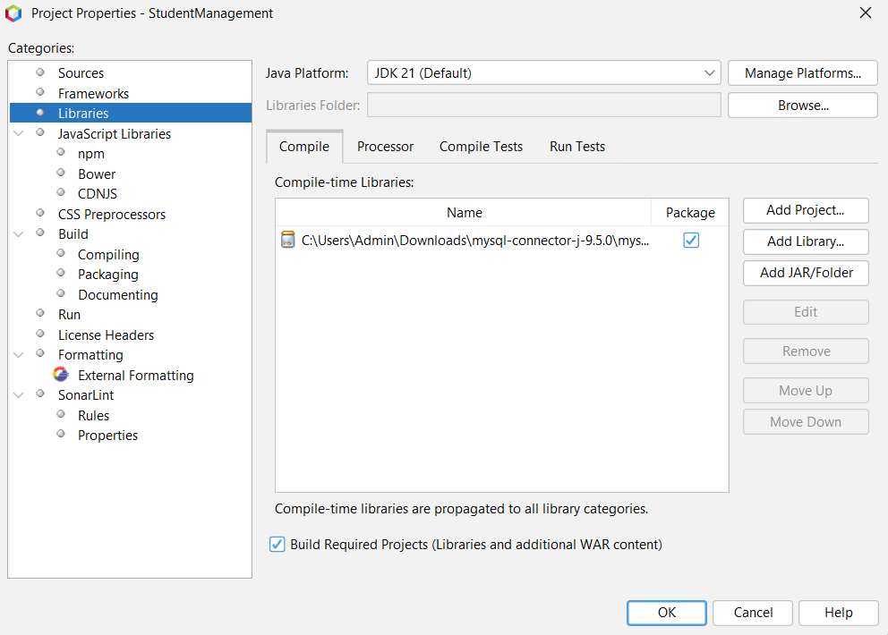
Figure 2: MySQL - Connector
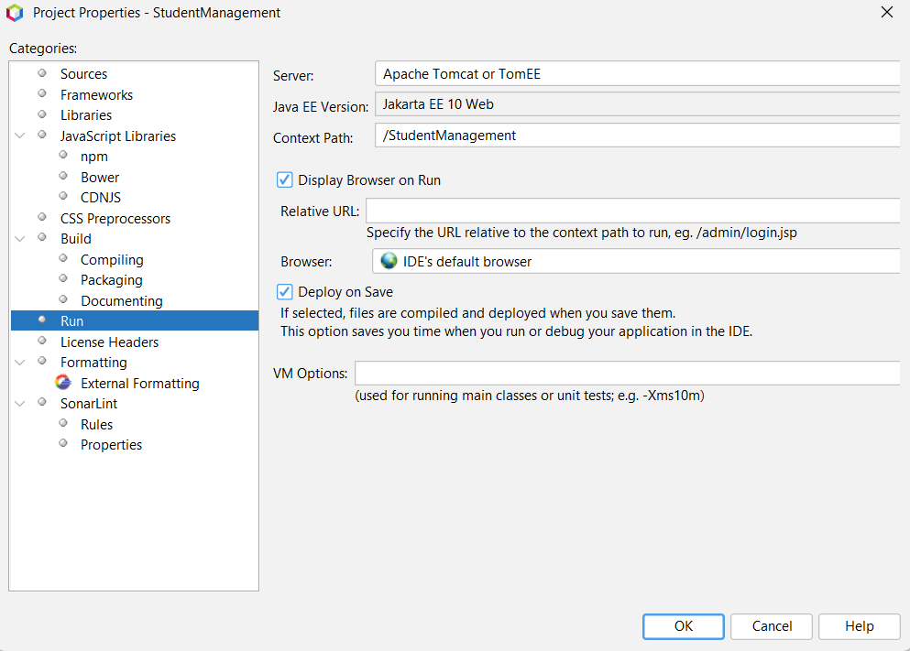
Figure 3: Server Apache Tomcat

Task 1.2: Display Student List
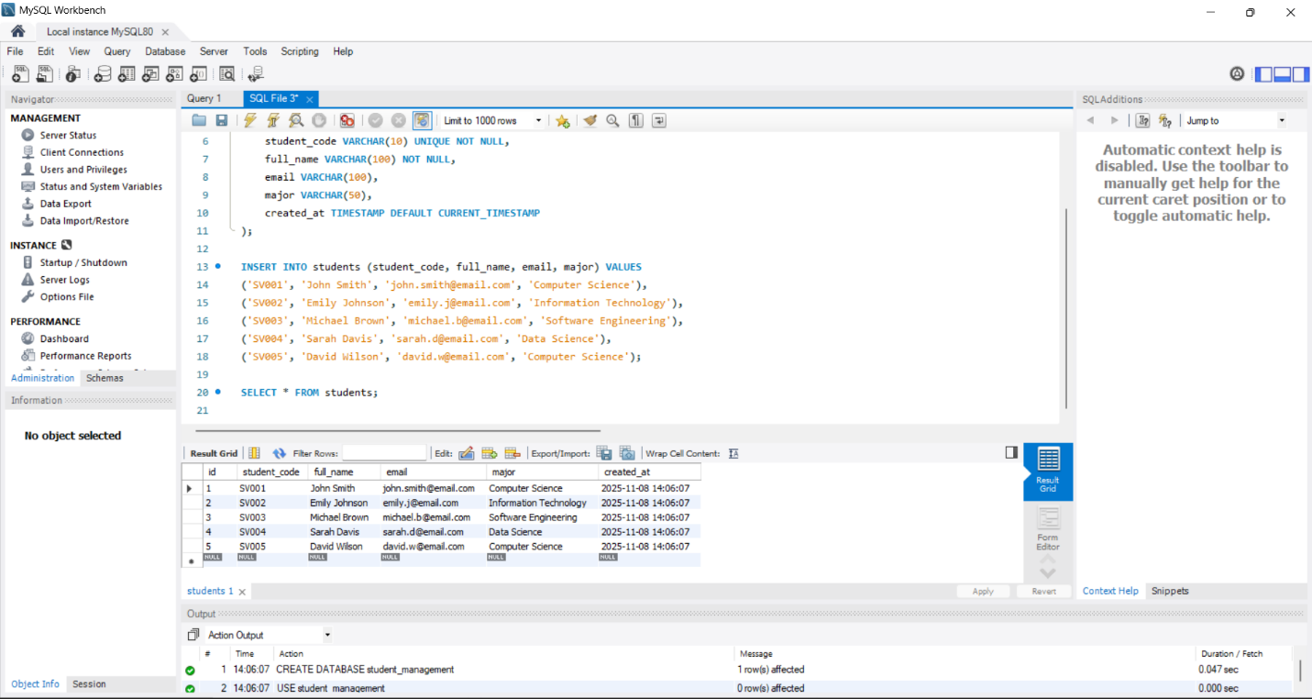
Figure 4: Database student_management

EXERCISE 2: CREATE OPERATION
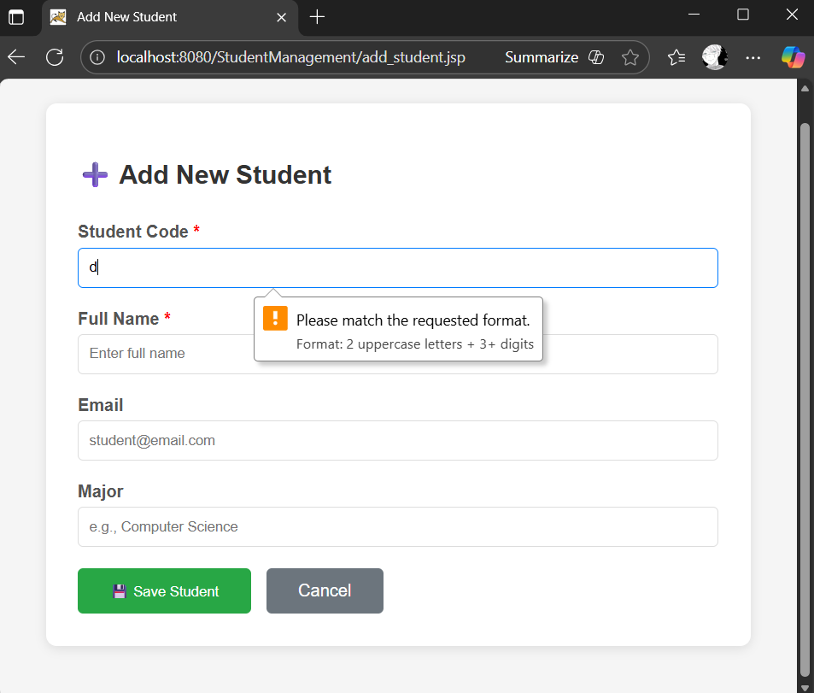
Figure 5: Add new student

EXERCISE 3: UPDATE OPERATION
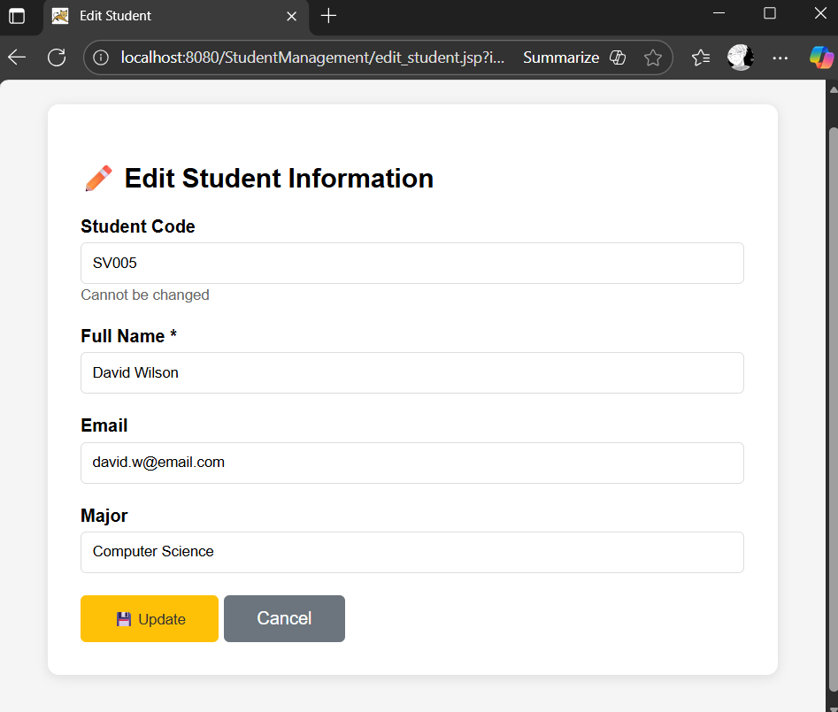
Figure 6: Edit student

EXERCISE 4: DELETE OPERATION
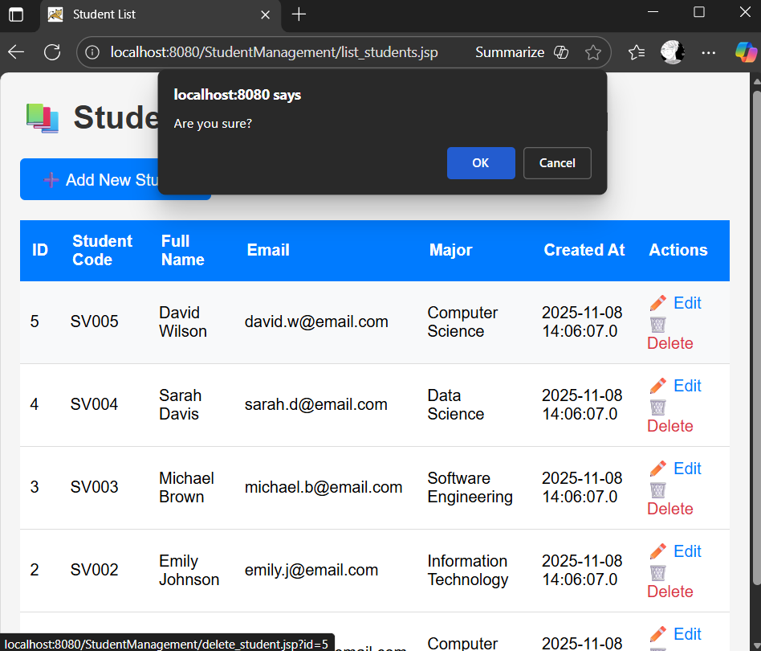
Figure 7: Confirmation dialog, Delete in red

DEMONSTRATION
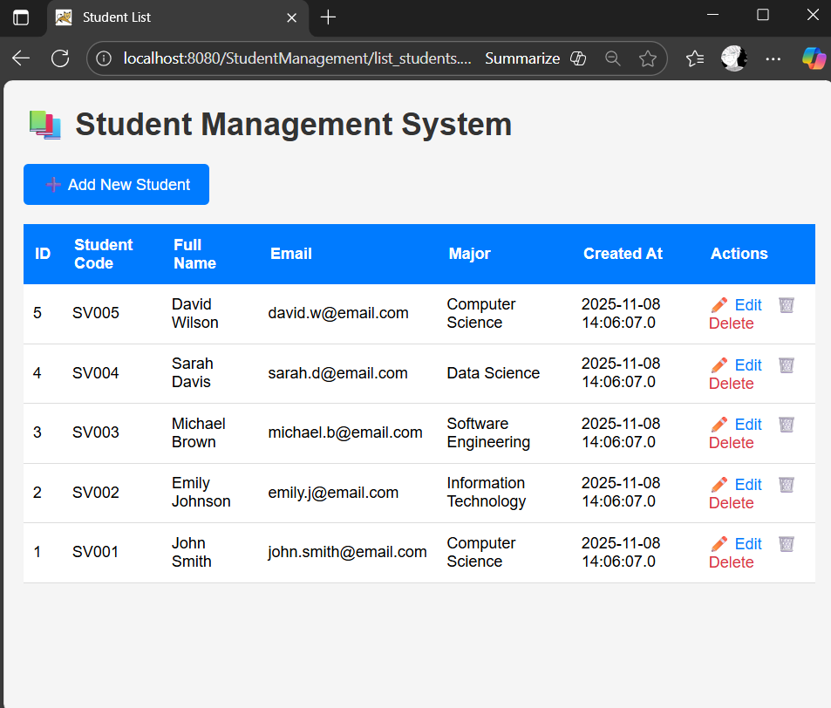
Figure 8: Student list
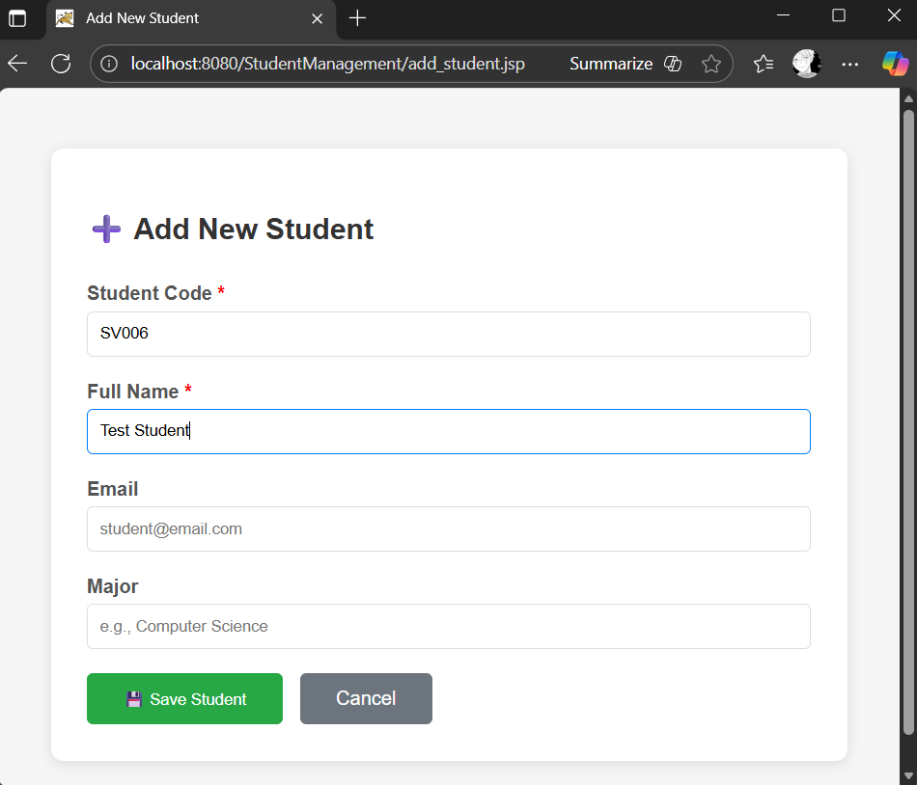
Figure 9: Add Test Student with code SV006
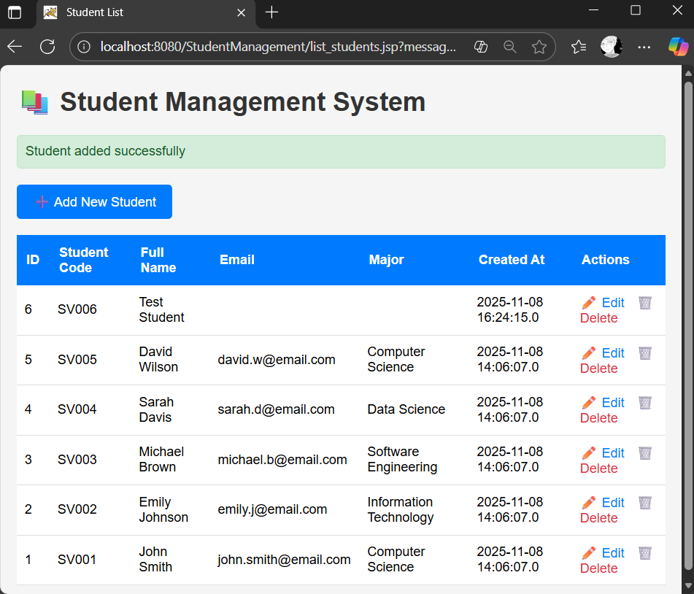
Figure 10: New student shown in Student list
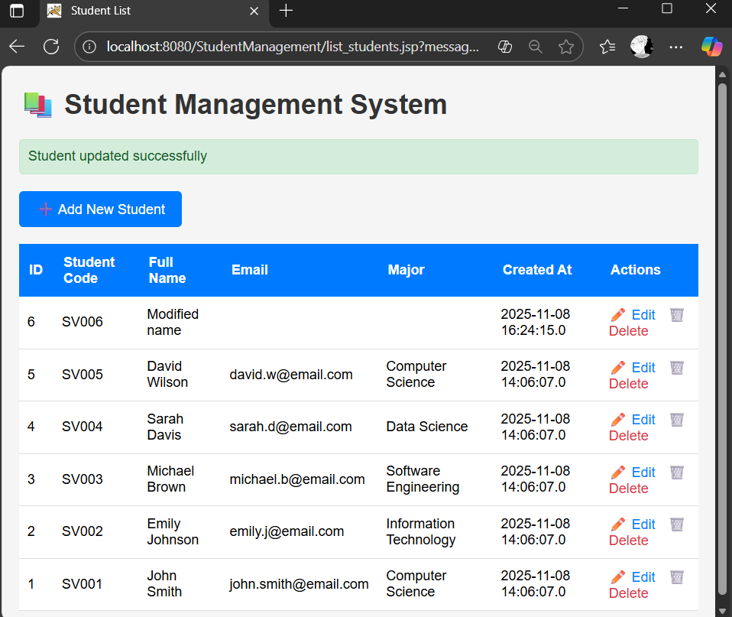
Figure 11: Edit and change “Test Student” name into “Modified name”
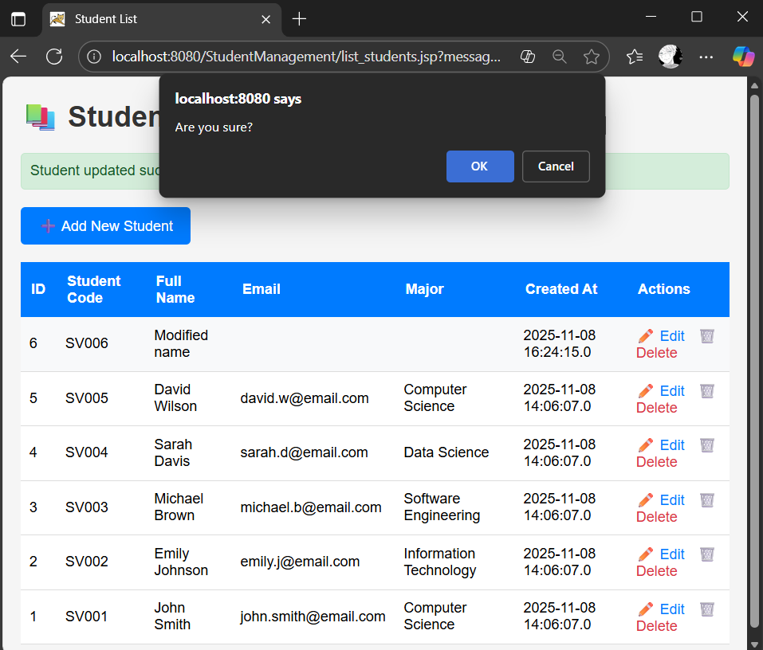
Figure 12: Confirmation dialog
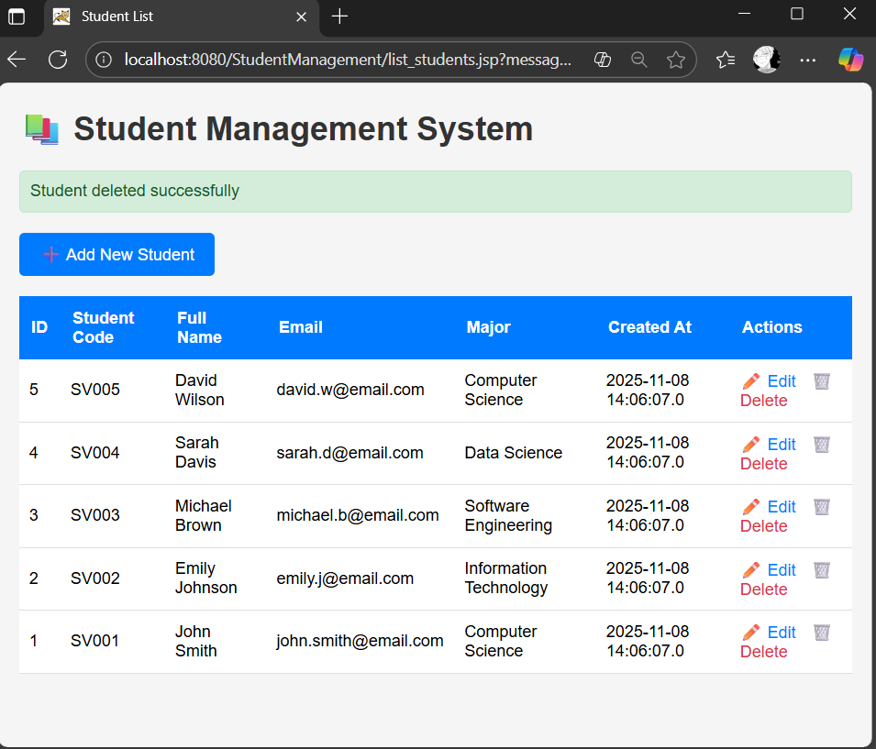
Figure 13: Student with code SV006 is deleted

